
Mobiquest Solutions Pte Ltd
6 Ubi Road 1, Wintech Centre #05-13, Singapore - 408726
Tel: 65-67493202, Fax: 65-67493212
Email: info@mobiquest.net
URL: www.mobiquest.net

Document | Eclipse – MobileFirst & Android Setup Guide
Release Version | 1.0
Release Date
Approval Date

VERSION HISTORY

Version # | Release Date | Description | Updated By
1.0 | 12th Dec | Eclipse – MobileFirst 6.3 setup guide | Reej

TABLE OF CONTENTS
1 Purpose 3
2 Eclipse setup 3
2.1 Installing Eclipse Kepler SR1 3
2.1.1 Download JDK 3
2.1.2 Install JDK and JRE 3
2.1.3 Download and Install Eclipse 3
3 Configuring Worklight studio 3
4 Eclipse Embedded Worklight Server 4
5 Android SDK Setup 6
6 Reference 7

Purpose
This document describes how to install Eclipse, configure the MobileFirst studio 6.3 and the eclipse embedded worklight server.

Eclipse setup
Juno SR2 (4.2.2), Kepler SR1 (4.3.1), or Luna (4.4) versions of eclipse are only supported by the IBM Worklight studio on Eclipse market place. Installing any other versions of eclipse will show errors. We are using the Kepler SR1 (4.3.1).

Installing Eclipse Juno SR2
To use Eclipse for java programming, you need to first install Java Development Kit

Download JDK
- Go to Java download site at http://www.oracle.com/technetwork/java/javase/downloads/index.html
- Click the download button under respective versions required.
- Check the Accept License Agreement.
- Choose your operating system.

Install JDK and JRE
- Run the downloaded installer, which will install both the JDK and the JRE.
- By default JDK will be installed in C:\Program Files\Java\jdk1.7.0_67.
- Set the Path Environment variable by editing it as below
  - Variable name: PATH
  - Variable value: C:\Program Files\Java\jdk1.7.0_67\bin; [other existing entries]

Download and Install Eclipse
- Download Eclipse Kepler SR1 from the eclipse downloads page.
- Download the appropriate downloads for the operating system - windows/Mac/Linux – 32/64 bit.
- Kepler SR1 can be downloaded from the below link http://www.eclipse.org/downloads/packages/release/Juno/SR2
- Unzip the downloaded file in the directory of your choice (d:\Juno_SR2)
- You can start working by clicking the eclipse icon in the folder

Configuring Worklight studio
MobileFirst Studio is the Eclipse based IDE for building worklight projects. It can be launched by starting the eclipse framework into which you will install the MobileFirst studio environment.
MobileFirst 6.3 is not available in market place, so we need to configure the plugin and iFix for studio 6.3 through the archive file provided by Sembcorp.
Refer: Installing_MFP_Studio_Plugin_and_iFix_v1.0.doc for the installation steps to follow.

Eclipse Embedded Worklight Server
Embedded instance of WebSphere Application Server Liberty profile is created when we install worklight studio. This acts a default test server. This application server has its configuration properties which can be changed if needed. The primary property is the port number, on which it is listening for browser requests. The default port number is 10080, however if there is any conflict, this port number can be manually edited by opening the server.xml

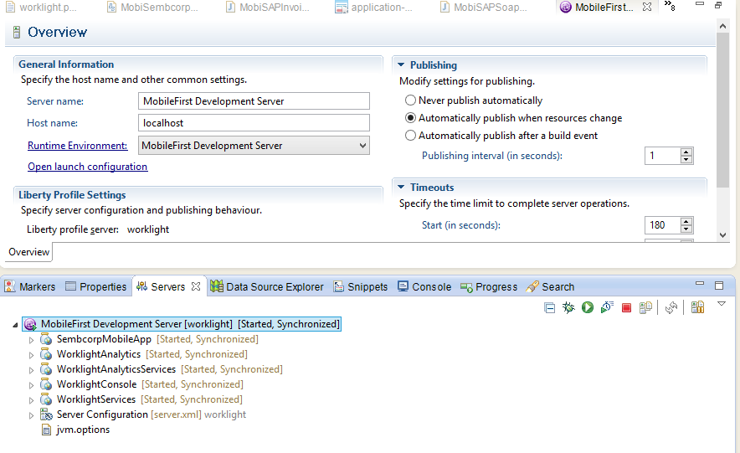

Run on MobileFirst development server is used to build and run an application in the test server.
It can be invoked by right clicking the application name inside apps Run As → Run on MobileFirst development server. When you choose, Run As → Run on MobileFirst development server, worklight studio performs the following actions:
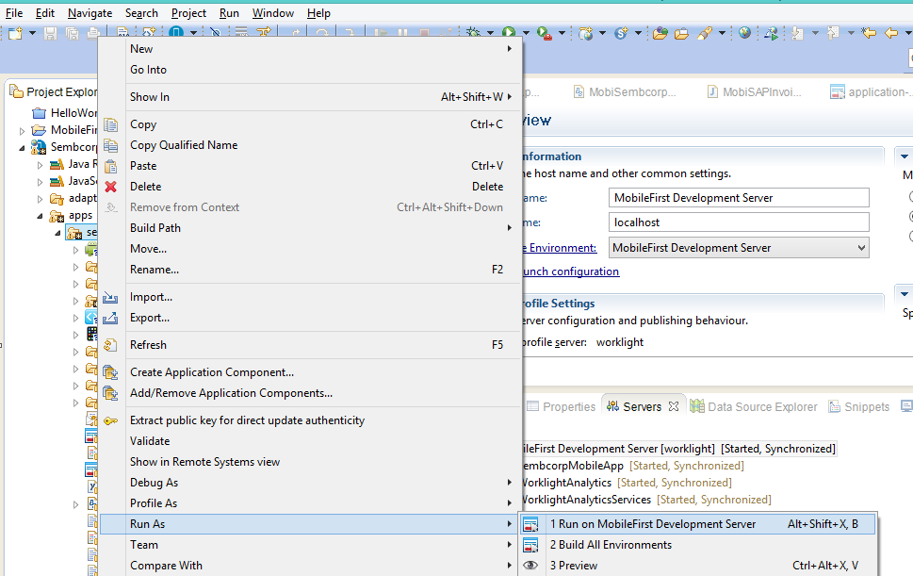

- Starts the MobileFirst development server, if not already started.
- Builds the app and all of its included environments.
- Deploys the app to the MobileFirst development server (embedded server) and reports success, failure and any error message in the console view of worklight studio.
- MobileFirst console can be launched by right clicking the project Open MobileFirst console
- When the MobileFirst console is opened, the console displays the successfully deployed app and all its environments.

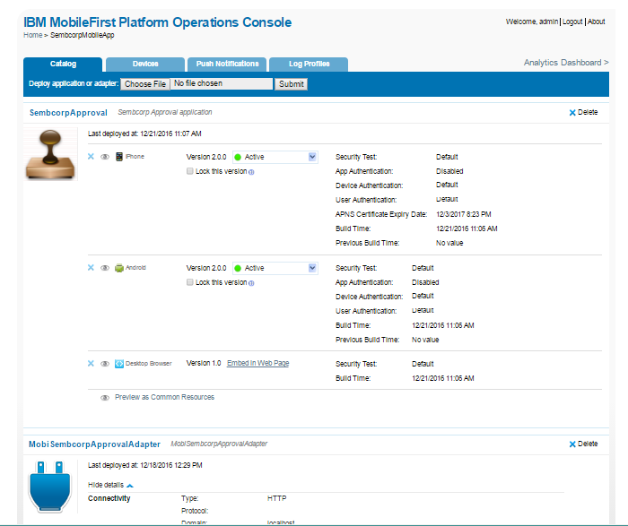

Note:
- Please refer the document “Building Worklight Project_v1.0.doc” for steps involved in building a worklight project.
- Please refer the document “4Worklight – Project Deployment.doc” for steps involved in deploying a worklight project to an external server.

Android SDK Setup
The following are the steps for setting up android sdk.
- Download and unzip Android SDK from http://developer.android.com/sdk/index.html#Other. Please find the corresponding SDK tools for your platform. For Mac, the package name is something like android-sdk_r24.0.2-macosx.zip .
- Run the Android SDK Manager from the from the tools folder. Run the file ‘android' from '‘path-to-sdk/tools/‘.
- Android SDK Manager lists all the android packages/APIs installed,
  - Check the APIs from API 14 to API 20.
  - Check ALL Android SDK Build-Tools rev 17 to 21
- Click Install to start installing all the android packages.
- Once installation completes all the files.

Reference
- http://marketplace.eclipse.org/content/ibm-worklight-studio#.VFbxp_mUdbc
- http://www-01.ibm.com/support/knowledgecenter/SSZH4A_6.2.0/wl_welcome.html
- http://public.dhe.ibm.com/software/mobile-solutions/worklight/docs/v620/02_01_Creating_your_first_Hybrid_Worklight_application.pdf

